CS 255 System Design Document

UML Diagrams

UML Use Case Diagram

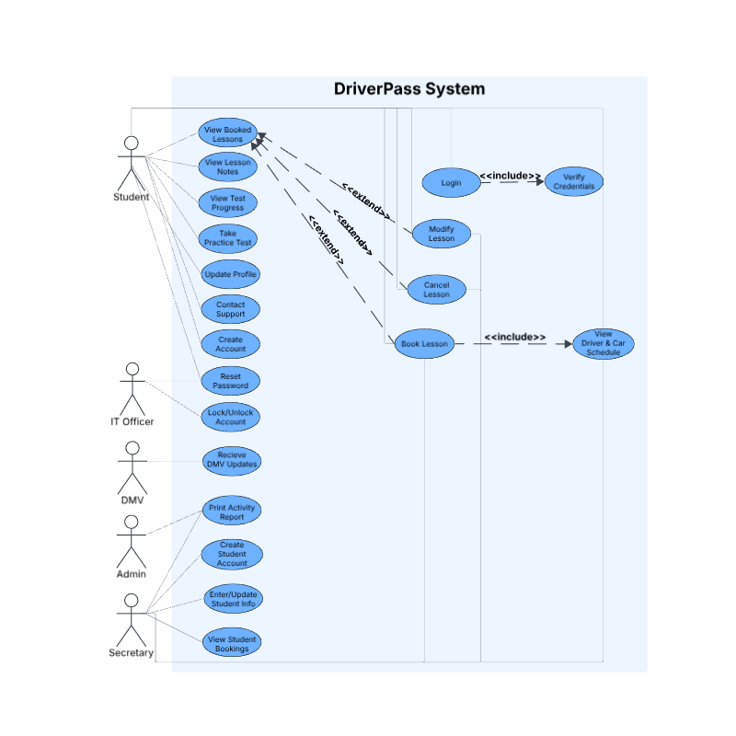

UML Activity Diagrams

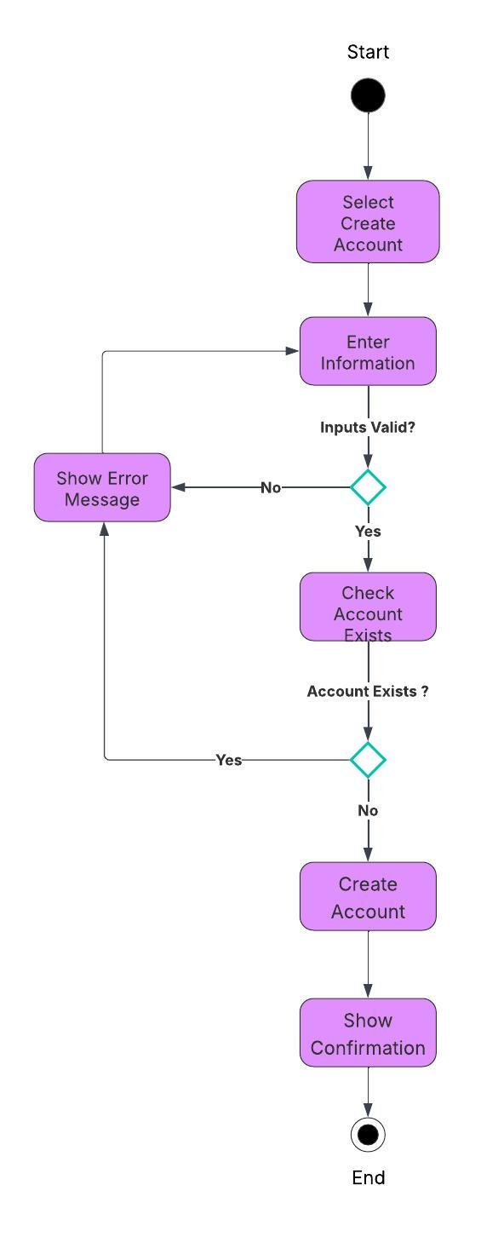
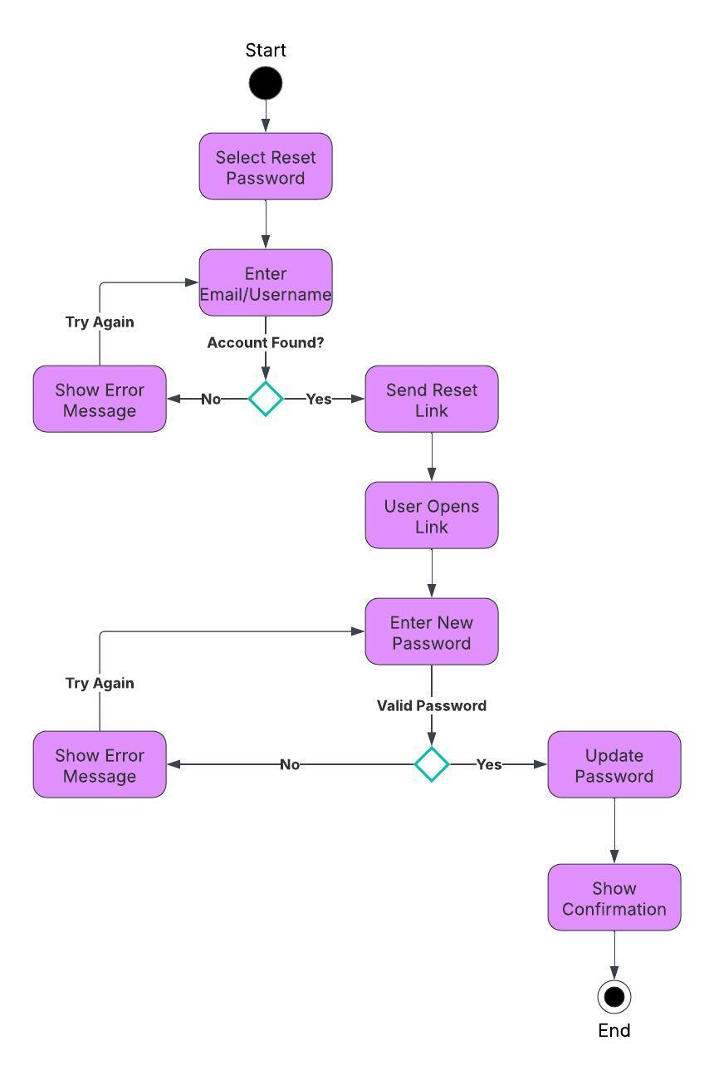

UML Sequence Diagram
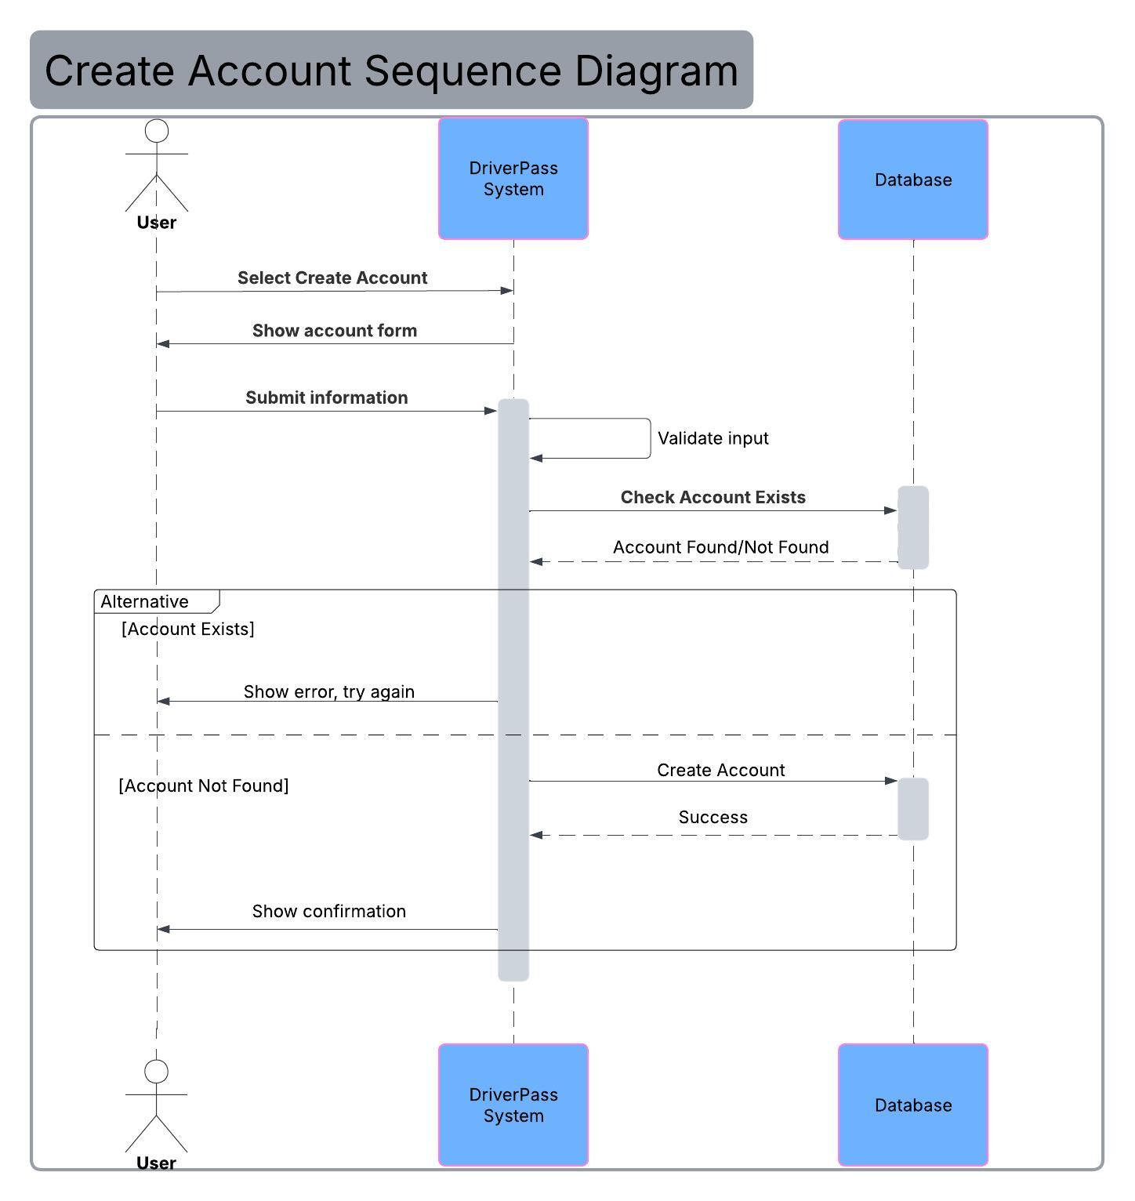

UML Class Diagram
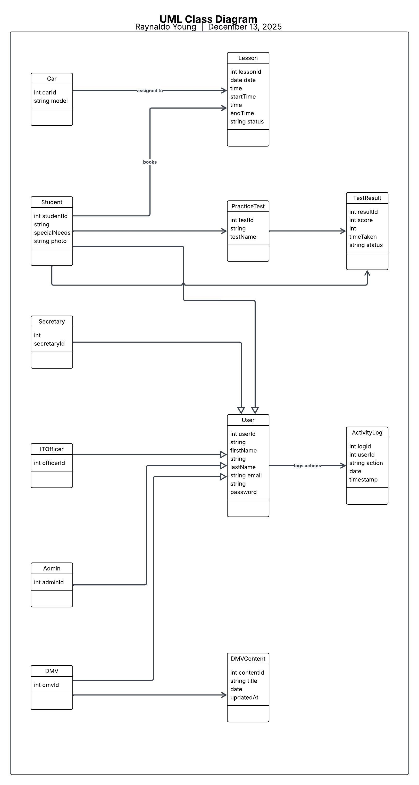

Technical Requirements

Hardware

- Cloud server with four CPU cores and eight gigabytes of memory for concurrent user activity.
- SSD storage for fast access to database tables such as User, Lesson, TestResult, DMVContent, and ActivityLog.
- End users require only a modern web browser on any standard device.

Software

- Backend framework such as Node.js or Java Spring Boot to handle authentication, account creation, scheduling, and test workflows.
- Relational database such as MySQL or PostgreSQL to store all entities defined in the class diagram.
- Frontend framework such as React or Angular to support user interactions from the use case diagram.
- SMTP or email service to deliver password reset links.
- Logging system for recording ActivityLog entries and system events.
- API layer for communication between frontend, backend, and database.

Tools

- UML design tools such as Lucidchart or Mermaid for maintaining diagrams.
- Version control system such as Git with GitHub or GitLab.
- Automated testing tools such as JUnit or Jest to validate system workflows.
- CI/CD pipeline tools such as GitHub Actions or Jenkins for deployment.

Infrastructure

- HTTPS with TLS to secure all user communication.
- Role based access control for Student, Admin, Secretary, DMV, and IT Officer.
- Authentication and credential verification services.
- Daily or scheduled database backups and recovery procedures.
- Monitoring and alerting for performance and system errors.
- Optional load balancer for scaling during high traffic.

